Abstraction

Abstraction in coding works with abstract data types, it’s like defining data structures with operations associated to it but without “showing” how the operations are implemented.
It’s good because you can work with the same data in different functions.

Here is an example

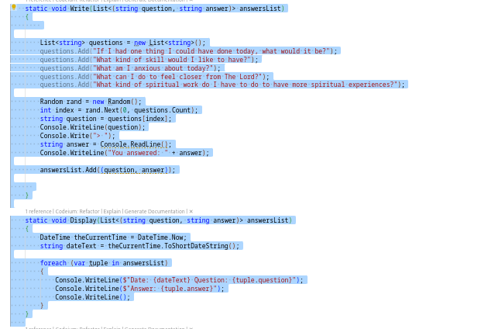
The function Write has 2 parameters, both of them are strings and they are named question and answer, but as we can see the function Display also have the 2 parameters, and it’s like this só that when you are executing this code specifically you can have the data you entered in the write function also in the Display function, and deppending on the situation you can work with the data in both of them

